THE LISTENING ROOM



The Story

In the year 2001, when the right place and the right time met Dr Bharati Chawathe, she started Spring Counselling and Psychotherapy Centre, in a quaint space in Khar, Mumbai. Here, she started the centre with a belief that the most effective way to promote positive change is to invest in an individual's growth and hope. The key belief that arises from a zen saying “spring will come and grass will grow”.

With an unwavering belief and commitment, she built a thriving practice, offering sessions, assessment, study circles, therapy groups and self-awareness programmes. Today, the centre has organically grown to become personal development space, a space of understanding and self-acceptance. This non-directive psycho-educational process has been working effectively through all these years, so much so that while the world was overcome with the pandemic where all known human interactions were challenged, Spring counselling and educational processes continued with gentle continuity. The new normal of online electronic mode through phones, tablets and laptops, was adapted instantly and seamlessly.

Today, the centre has over 25 counsellors, 2700 clients spread across over 20 countries and over 65,000 thousand of hours of counselling sessions and educational workshops catering to individuals, couples, families and corporates. A community was slowly and strongly being formed.

All the experiences gave rise to what can be referred to proudly as the “spring method”. A method that sets Spring Counselling and Psychotherapy Centre apart- a combination of assessments, sessions, study circles, therapy groups and self-awareness programmes. An in-house study conducted among the clients reiterated that Spring method was highly effective wherein the clients got a space to reflect, contemplate, introspect, and build their emotional and cognitive well-being.

Nearly two decades later, amidst an unprecedented global crisis, the core team at Spring analysed data from the thousands of counselling hours they collectively had under their belt. Clients wholeheartedly supported this project and provided their feedback on the effectiveness of ‘the Spring method’. The core question that the team set out to find answers to was what sets Spring apart.

While on one hand, the findings of the study renewed the collective energy at Spring and strengthened the belief in their method, it also suggested that it was time to take this further into the new age of new normal a new reality brought about due to the pandemic. Once again an opportune moment of right time, right place and right people coincided and gave rise to The Listening Room.

The Listening Room- established in 2023 is “a space to be heard”, An online platform designed to make counselling available via electronic mode through phones, tablets and laptops, which have become the epicentre of human interactions/existence. TLR provides an online safe listening space to enable individuals and groups to get in touch with their true/authentic self, by accepting themselves for who they are, becoming more functional in their daily lives, finding their own uniqueness and thereby realising their potential to contribute better to their environment.

Counsellors of TLR are trained to be active listeners, using empathy, acceptance and understanding. All this backed with the subject matter expertise deeply rooted in the science of psychology.

TLR has deliberately chosen the Elephant as its mascot, where the herd walks together so as to provide a safe environment for every member of the group to grow. The belief that our strength is active listening and this core value is the foundation of empathy and understanding. Like the Elephant, our chosen mascot, we believe in creating a community and walking together towards our common goal of bringing about a positive change by investing in our individual growth.

**Assessment Questionnaire:**

Assessing mental illness is a complex process that should be conducted by trained professionals such as psychologists or psychiatrists:

1. Have you experienced any recent life changes or stressful events?
2. Have you noticed any significant changes in your mood or emotions?
3. Do you frequently feel sad, anxious, irritable, or empty?
4. Have you noticed any changes in your sleep patterns (insomnia or excessive sleep)?
5. Have you experienced any changes in your appetite or weight?
6. Do you engage in any self-destructive behaviours (e.g., self-harm)?
7. Have you been experiencing difficulties with your memory, concentration, or decision-making?
8. Do you have recurrent negative thoughts or persistent worries?
9. Have you noticed any disorganized or racing thoughts?
10. Have you experienced a loss of interest or pleasure in activities you used to enjoy?
11. Have you noticed any significant changes in your social behaviour?
12. Do you find it challenging to engage with others or maintain relationships?
13. Have you noticed any changes in your energy levels or motivation?
14. Are you struggling with any sexual or reproductive health issues?
15. Do you use any substances (alcohol, drugs, etc.) to cope with your emotions or mental state?

FREQUENTLY ASKED QUESTIONS:

1. What are the services offered by you

A. Individual counselling

B. Psycho education on various areas for mental health

C. Retreats

2. What is your counselling process

This is a talk therapy approach where the counsellor helps the client assess and address mental health issues

3. How many sessions are required

A minimum of 5 sessions

4. What are the charges

Rs 10,000/-

5. What is the payment method

There is a payment link on this website

6. Do I have to do payment in advance for all the sessions

Yes, the charges for all the five sessions are paid in advance from you to start sessions wit our counsellor

7. If I want to discontinue the sessions, will I get the refund

Yes, after deducting the amount for actual sessions taken, the amount will be refunded to your account

8. Is there any tax on the payment

Yes, GST is included

9. How do you conduct these sessions

We conduct 5 sessions online with the client so as to help him/ her assess and address his emotional or behavioural issues

10. What is your approach

There are different schools of thoughts that we take help from while conducting the sessions.

* Client - centered theory by Carl Roger
* Gestalt Theory by Frederick Perls
* Psychodrama by J. Moreno
* Transactional Analysis by Eric Berne
* Psychoanalytic Theory of Sigmund Freud
* Analytical Psychology of Carl Jung
* Eric Erickson's theory on stages of development along with
* Abraham Maslow's theory of Hierarchy of Needs and
* Existential Humanistic Theory

 11. How is the counselling process for one issue different from the other

The process of identification of the issue is the same. Once we assess then the concerned issue will take different approach on case to case basis

12.. Do you practice CBT

No

13. Do you practice DBT

No

14. Do you do counselling for OCD

Yes. It usually requires long term counselling, depending upon the intensity of the issue

15. Do you do counselling for Grief

Yes

16. Do you do counselling for Eating Disorder

Yes

17. Do you do counselling for Depression

Yes

18. Do you do counselling for Anxiety

Yes

19. Do you do couple counselling

Yes

20. Do you do Coaching

No

21. Do you have Lifestyle Management Coaches or Counsellors

Yes

22. What is the difference between Counselling & Coaching

Coaching requires a lot of readiness to take responsibility of the concerns and active approach. Whereas, counselling is slower approach and we wait till client gets ready to solve his problem area

23. Who are the counsellors

Our counsellors are well trained and experienced in this profession (See more details)

24. Do I have to see the same counsellor in every session or different counsellor in different sessions

You will be meeting the same counsellor once you are allocated with the counsellor

25. Can I ask for a different counsellor, If I don’t like the assigned counsellor

Yes

26. How many sessions will be required

We begin with 5 sessions and you can extend the sessions if required

27. Will I continue with the same counsellor

Yes if you choose to

28. How long is the counselling process

It is not possible to define the time window. It is up to the client to make that call after few milestones are achieved

29. How effective is your method

We have been testing our method for 25 years and it is found to be effective by many of our clients (We have an audit done by external party for the effectivity of our counselling processes … see more)

30. Are the sessions confidential

Yes

31. What measures are taken to keep confidentiality

The counsellors sign an agreement of non – disclosure with the company (See Details)

32. How experienced are the counsellors and the clinic

Most our counsellors have experience of over 5 years

33. How effective is an online counselling

We conducted a research study with our clients during recent pandemic and it has been proved very effective (See details)

34. Where is the physical clinic

Our office is at Khar West, Mumbai

35. What is the guarantee that the mental issues will get resolved

We do not give any guarantee, however, our client testimony is safe explanatory

36. What is the guarantee that the mental issues will not resurface

We do not give any guarantee, sometimes under stress of similar nature that you have gone in past, the issues may resurface and we have to restart the process

37. I heard that XYZ counsellor is good. Will I be given the same counsellor or different?

We will try to keep your request for the same counsellor in mind. Based on availability and the nature of your issue, counsellors are allocated

38. Do you give medication

No. We suggest a psychiatrist or other medical professional for the medication

39. Do you speak with the family members if they call you

No. Unless, there is any emergency and we have to speak with them

**Training the People Involved**

Who are the people?

* Counsellors
* Interns
* Supervisors
* Support groups
* Helplines - suicide prevention, psychiatry, other helping methods

Who will be the counsellor – the aptitude and attitude

* Listener
* Good Cognition
* High emotional quotient
* Appearance
* Life experiences
* Self work

Who will be the supervisor

* Quality Control
* Good Cognition
* High emotional quotient
* Self regulation and regimentation
* Self work

**Founder:**

**Dr Bharati Chawathe**

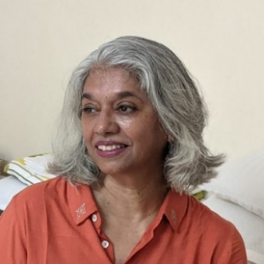

Bharati has a Ph. D. in Psychology and a degree in Education Management along with diploma in Higher Education from Bombay University.

She started as a lecturer, in Bhavan’s college and later moved on to teach at the Post Graduation Department of the University.

In 1996 she became the Head - Post - Graduation Department of Education Management in Janaki Devi Bajaj Institution of Management Studies.

She has been a Consultant and a Visiting faculty at Tata Institute of Social Science, Academic Staff College, University of Bombay, the Hinduja, Jaslok, Harkisandas, Sion, Nair Hospitals in Bombay as well as a number of NGOs in past, for various Counselling, Team Building, Motivational and Behavioural Therapy programs.

Her research experience is from her personal research work and the project guidance that she has extended on different areas ranging from management of human resource to organizational development exercises to system development exercises.  
  
She established SPRING as a counselling and coaching centre in September 2001

Counsellors:

1. **Amruta Pinjarkar**

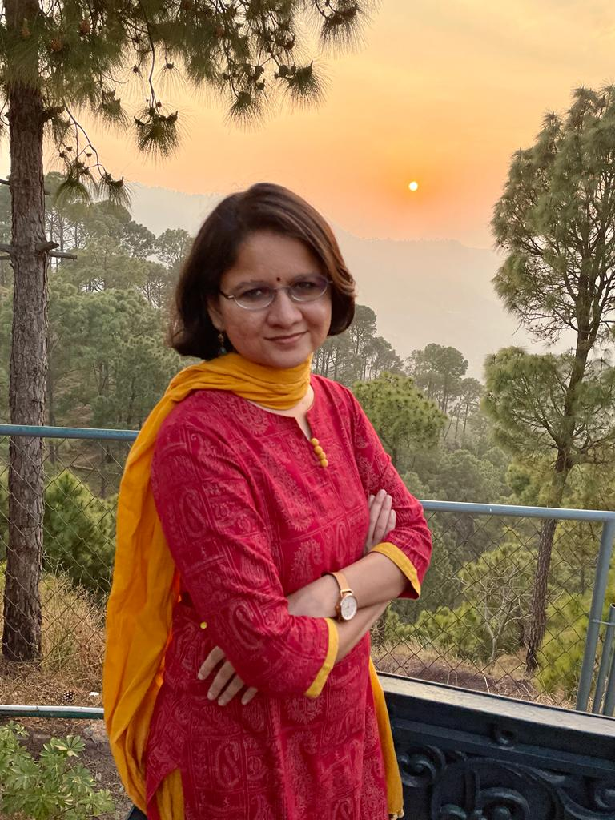

**Years of Experience:** 6 years

**Number of Sessions Taken so far:** Over 1500

**Languages:** English, Hindi, Marathi

**Educational Qualifications:** Masters in Counselling Psychology, Masters in Labour Studies

**Specialisations:** Adults dealing with stress, anxiety, grief, depressive symptoms, chronic ailments, psychosomatic problems, teens and parents, couples/ relationship counselling, women’s issues at various life stages. Amruta is in the counselling profession by choice and not by chance.  As an avid learner of mind and emotions for many years, she has helped clients understand and help them navigate in their emotional world better. Apart from western psychology, she uses eastern psychology, yoga, dreams and visuals in her sessions to explore the expanse of mind. Her sessions involve a lot of listening, a bit of psycho-education with a dash of humour.

1. **Anuradha Shah**



**Years of Experience:** 4 years

**Number of Sessions Taken so far:** Over 2500

**Languages:** English, Hindi, Gujrati, Marathi

**Educational Qualifications:** Master’s degree in Management Studies from Mumbai University, a degree in Counselling Psychology, certified in Narrative Psychology, training and fellowship with Sumedhas Academy of Human Context. She is a certified practitioner of MBTI, FIRO-B, and EUM Suite of instruments.

**Specialisations**: Adults with depression, anxiety, grief, relationship issues, work issues. Anuradha was motivated towards understanding identity and growth in young adults and thus pursued training in process-oriented psychology. She has worked with academic institutions, corporates, and development organisations in various capacities to facilitate mental health, transformation, and learning. She enjoys chatting about books, movies, music, poetry, politics, technology, and just about anything under the sun. She’s happiest soaking in art of the subcontinent and finds deep resonance in Sufi and Urdu poetry.

1. **Dwijatha Somayajula**

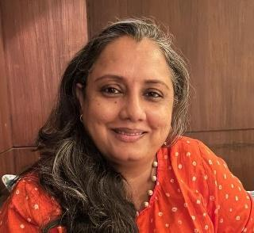

**Years of Experience:**  12 years

**Number of Sessions Taken so far:** Over 7000

**Languages:** English, Hindi, Tamil, Telegu

**Educational Qualifications:** Masters in Mathematics from IIT Madras, PGDM from IIM Bangalore, Masters in Psychology, Training in REBT

**Specialisation:** Individuals, families, children/parents, couples, life-stage transitioning individuals, addiction, long-term illness management and grief management

1. **Esha Bhojwani**



**Years of Experience:** 9 years

**Number of Sessions Taken so far:** Over 1500

**Languages:** English, Hindi

**Educational Qualifications:** BA in Psychology (Mumbai University), Masters in Social Work and Counselling (University of Hong Kong), PG Diploma in Counselling Psychology (XICP).

**Specialisations:** Individuals, couples, dealing with anxiety, depression, grief and relationship and work issues. She approaches sessions in a holistic and person-centred way, with an aim to help clients come to a better understanding and acceptance of self.

1. **Liya Gupta**



**Years of Experience:** 5 years

**Number of Sessions Taken so far:** Over 1600 sessions

**Languages:** English, Hindi, Bengali

**Educational Qualifications:** MA Psychology degree in Counselling, MBA, XLRI Management PGDHRM PCC- Professional Certified coach from International Coaching Federation, MBTI Neuroscience, Transaction Analysis, Enneagram Certified and also a practicing coach.

**Specialisation:** She is passionate using different methodologies of neuroscience and human behaviourist skills. She uses enquiry methods, helps clients with compassion to move out from their comfort zone

 Individuals, Couple counselling, Women going through difficulties, she approaches sessions with holistic and person-centred way with an aim to help clients come to a better understanding and acceptance of self.

1. **Neil Soans**

**Years of Experience:**4 Years

**Number of Sessions Taken so far:**  Over 500 sessions

**Languages:**English

**Educational Qualifications:** PG Diploma in Guidance and Counselling, MBA in Marketing

**Specialisation:** Dedicated to exploring the depths of the human mind while empowering individuals to become emotionally competent. Currently focused on handling anxiety, stress, depression and relationship issues, with prior experience counselling men with HIV/ AIDS, including weekly workshops on sex education and safe practices.

1. **Dr Pratibha Patil**



**Years of Experience:** 6 Years

**Number of Sessions Taken so far:**

**Languages:** English, Hindi, Marathi

**Educational Qualifications:** Homeopathic doctor since 1995

**Specialisation:** Adults, Teens and Parents

1. **Priya Chandna**

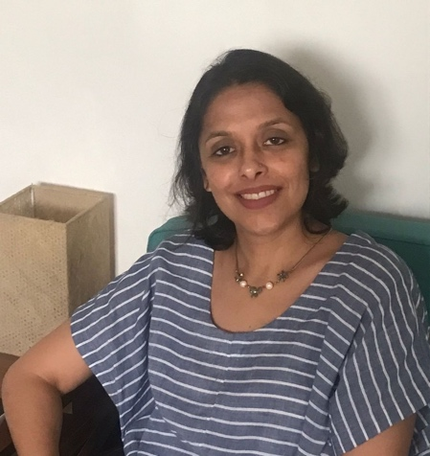

**Years of Experience:** 6 Years

**Number of Sessions Taken so far:**  Over 3000 sessions

**Languages:** English, Hindi

**Educational Qualifications:** Course in Counselling Psychology, Master in Human Resource Management

**Specialization:** Adults dealing with Depression, Anxiety, etc and Couples therapy. Priya approaches each client with curiosity about their inner world and uses various tools such as Transaction Analysis, etc. Priya finds it gratifying to work with individuals on developing a deeper understanding of themselves and in helping them navigate their own journeys.

1. **Priya Kehair**



**Years of Experience:**3 Years

**Number of Sessions Taken so far:**  Over 750 sessions

**Languages:**English, Hindi

**Educational Qualifications:** Master’s degree in Management Studies, Master’s degree in Psychology, Diploma in holistic Counselling Psychology, Training in Rational Emotive Behaviour Therapy and Rogerian therapy

**Specialisation:**Client-centred therapy forIndividuals, children/parents, couples, relationship management, life-stage transition management, education/career goal management  – Priya K uses a unique, practical and customized approach that helps individuals, across age groups and cultures, in navigating their journeys, crossing desired milestones and charting new paths with a renewed vigour and resilience.

1. **Revati Raja**



**Years of Experience:**7 Years

**Number of Sessions Taken so far:**  Over 2000 sessions

**Languages:**English, Hindi, Malayalam

**Educational Qualifications:** Masters in Counselling Psychology from Christ University Bangalore. She has a diploma in music therapy and has completed course work in Applied Behavioural Analysis.

**Specialisation:** Eclectic approach using talk therapy, play therapy, music therapy. She works with Adults, teens, children and parent clients with mild, moderate and severe behaviour and emotional concerns. She is empathetic, passionate and believes each client is unique. She tailors her approach based on the client’s life experiences.

1. **Rina Mehta**



**Years of Experience:** 5 Years

**Number of Sessions Taken so far:**  Over 2100 sessions

**Languages:** English, Hindi

**Educational Qualifications:** Bachelors in Economics Honours, Masters in Counselling Psychology, she is certified in REBT, Transactional Analysis, Integrated Counselling and other therapies with the Institute of Human Technology. She is also a qualified Professional Coach from the Leadership that Works and has completed her Post Graduate Certificate Programme in Couple and Family Therapy from TISS.

**Specialisation:** Individuals, Couples, and Adolescents, she is motivated by a deep empathy for those who strive to maximize their lives through self-awareness, and a desire to support their spiritual and professional journeys. She has been involved in educational endeavours, along with corporate and media experience and finds that this helps her relate deeper to her clients’ realities, including anxiety, depression, trauma, family and professional matters.

1. **Samay Ajmera**



**Years of Experience:** 6 Years

**Number of Sessions Taken so far:**  Over 800 sessions

**Languages:** English, Hindi, Gujrathi

**Educational Qualifications:** Masters in Psychology, professional certified coach with the International Coaching Federation, and a trained music therapist

**Specialisation:** With a deep understanding of the complexities of the human psyche and extensive hands-on experience working with individuals (ages 10-45yrs) facing psychological distress, Samay provides one-on-one assistance through a client centric and non-directive approach to individuals seeking to align their inner and outer selves and live a more fulfilling life.

1. **Saumya Dixit**

**Years of Experience:** 3 Years

**Number of Sessions Taken so far:**  Over 100 sessions

**Languages:** English, Gujarati, Hindi, Marathi

**Educational Qualifications:** Master’s degree in Psychology, Master’s in Management, ICF certified Coach (ACC), NLP practitioner, certified in CBT and REBT

**Specialisation:** Individualsacross various age groups. Saumya works enthusiastically with clients and facilitates them in creating self-awareness and developing deeper understanding of themselves. Facilitates them in achieving their life and / or work goals through personal challenges.

1. **Shaheen Allabux**

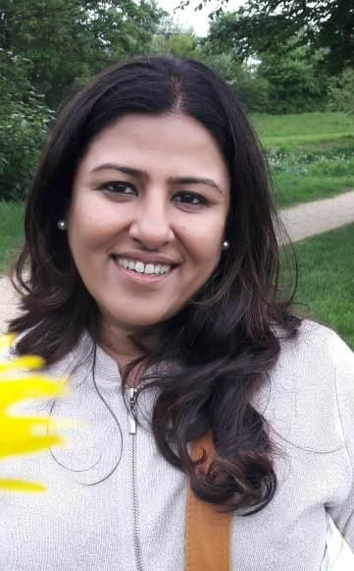

**Years of Experience:** 4 Years

**Number of Sessions Taken so far:**  Over 1500 sessions

**Languages:** English, Hindi, Gujarati

**Educational Qualifications:** A trained art-based therapist, she values art, drama and music as an integrative health service**.** She is trained in Yoga Philosophy and Art Based Therapy.

**Specialisation:** She likes to combine Yogic philosophies, psycho-education and play-based methods to build a therapeutic relationship with her clients. She has worked with various age groups handling issues related to individuation, academic performance, career pathways, familial and marital challenges etc.

1. **Susan Phillips**



**Years of Experience:** 12 Years

**Number of Sessions Taken so far:**  Over 4000 sessions

**Languages:** English, Malayalam

**Educational Qualifications:** Masters in Psychology. She also holds a Masters in English Literature and an M. Phil in Linguistics**.** She has also attended workshops on Child and Adolescent Psychotherapy from Bangalore

**Specialisation:** Susan Phillips is a trained relational Gestalt therapist from the Pacific Gestalt institute, Los Angeles. She is a play therapist for young children, and a life coach. She practices an integrated and relational approach with her clients. Her clients include young children from the age of 3, teenagers, young adults, couples, and senior citizens.

1. **Sweta Fernandes**

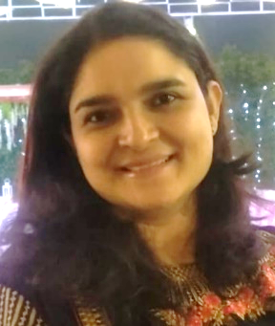

**Years of Experience:** 20+ Years

**Number of Sessions Taken so far:**  Over 5,000 sessions and over 1,000 assessments.

**Languages:** English, Hindi, bit of Sindhi and Gujarati.

**Educational Qualifications:** Master’s Degree in Applied Psychology (Clinical) from Mumbai University in 2001.

**Specialisation:** She has experience in providing psychotherapy and tele-therapy (Online) for individuals, couples and families of diverse age groups. Her approach to therapy is non-directive, client-centric, and frequently includes the use of Potential Assessment and Psychometric Assessment tools that help individuals gain insights into their own abilities and mental makeup.

1. **Uma Poddar**



**Years of Experience:** 6 Years

**Number of Sessions Taken so far:**  Over 800 sessions

**Languages:** English, Hindi

**Educational Qualifications:** Masters in Psychology, Masters in English Literature, PGD in Advertising and Marketing Communication.

**Specialisation:** Individuals, Couples. Her therapy method revolves around building relationships at all levels of existence, which she strongly believes can be nurtured and nourished with the right understanding in self and through self the other. She is an avid Vipassana follower

1. **Vibha Chokhani**



**Years of Experience:**4 Years

**Number of Sessions Taken so far:**  Over 1000 sessions

**Languages:**English, Hindi

**Educational Qualifications:** Masters in Business Administration (USA), Bachelor in Management Studies (Mumbai University), Associate Certified Coach (ACC) from International Coaching Federation.

**Specialisation:**A lifelong learner of mind and body connection (mainly through practice of Vipassana meditation), she has helped clients understand their emotional experiences better. Supports adult men and women with depression, anxiety, grief, relationship issues, work issues. She approaches sessions with a holistic whole-person focus with an aim to help clients come to a better understanding and acceptance of self. She believes people are naturally creative, resourceful and whole. She is also a practicing leadership & life coach for individuals and teams.

1. Archana – To be Added

Testimony:

Name: Shirin Sachdeva

Profession: HR Professional

Experience with the Counsellor: When I first started therapy I wasn't sure if therapy was right for me but it was the best decision I have made so far. My counsellor Sweta Fernandes is compassionate, patient and highly knowledgeable. She gave me the comfort to open up to her from our very first session. She helped me identify my triggers and patterns and showed me the ways to navigate through them on my own.

My sessions with Sweta have always been empowering and transformative to say the least. Sweta is a wonderful counsellor and an incredible human.

Experience with Spring: My journey with Spring has been extremely pleasant and seamless. I have never faced any issue while booking or rescheduling appointments.  The entire team of Spring has been very accommodating and flexible. I cannot recommend them highly enough.

Name: Dhaval Ajmera

Profession: IT Office worker

Experience with the Counsellor:  I've been taking sessions with Sweta Fernandes  since a few years, and my experience has been nothing but positive. She has a grace that instantly puts you at ease when you meet her. Her non-judgemental acceptance of me as an individual has over the years helped me examine aspects of myself that were buried under layers of negative emotions, slowly enabling me to improve my quality of life. I'm left impressed with her depth of knowledge in the field of psychology, which is evidenced when she picks up a statement, I have said casually without too much thought and explains my mindset behind it. Sessions are an invitation to explore the areas that cause hiccups in daily life, no issue is too big or too small. My sessions are never rushed through, and I have always left feeling heard; meeting her is like meeting an old friend who treats you as an equal, and not as someone in need of fixing. Today, I feel much more empowered to tackle my life's situations, and also confident that Sweta is a quick call away should an emergency arise.

Experience with Spring: My experience with Spring has been a good one. Their respect for each individual as a person is experienced from the first interaction. At the outset I was given all information regarding the process of in-take, timings, charges, etc, and my doubts were clarified. I appreciated the efforts taken to make me feel comfortable, including offering refreshments. The fact that they accept multiple payment options is a good convenience. The ambience of Spring is welcoming, and the vibe is calming and positive; I have always seen kind, smiling faces here. Their garden at the back is one of my favourite spots.

Name: Mihir Pradhan  
Profession: IT engineer, currently studying Masters

I am writing this testimony to express my utmost gratitude for the incredible experience I had with Counsellor Sweta Fernandes. My time spent with her was nothing short of life-changing, and I am forever grateful for the positive impact she has had on my mental health and overall well-being.  
When I first sought out Sweta's guidance, I was struggling with a myriad of emotions and feeling overwhelmed by the challenges life had thrown my way. I felt lost, unable to understand my own emotions and disconnected from everyone.

From our very first session, Sweta created a warm and welcoming environment that immediately put me at ease. Her empathetic and non-judgmental nature allowed me to open up and share my deepest fears and concerns without hesitation. She truly listened to me, validating my experiences and emotions, and helping me to gain a better understanding of myself. She helped me to explore my thoughts and feelings in a safe space, providing me with the tools and techniques necessary to navigate the complexities of my emotions. Through her insightful guidance, I began to uncover the root causes of my struggles, enabling me to address them head-on.  
One of the most remarkable aspects of my experience with Sweta was her unwavering support and genuine care for my well-being. She consistently went above and beyond to ensure I felt heard, understood, and valued.

I have experienced tremendous growth both personally and emotionally. I have gained a deeper understanding of myself, my triggers, and my values. I now possess the tools to manage stress, regulate my emotions, and make healthier choices.   
I wholeheartedly recommend Counsellor Sweta to anyone seeking support, guidance, and healing. Her professionalism, compassion, and expertise in the field of counseling make her an exceptional therapist.

Thank you, Sweta, for the transformative experience you provided me.

Name: Tejas Shah

Profession: Business

I was introduced to Ms Sweta by my father, in the year 2004 mainly due to my falling grades and lack of confidence in my personality. My father has taken many great decisions for me till I could take mine, but to go to Sweta in my tough time, is probably right there at the top.

Sweta handled my situation so calmly and responsibly that till date, if there's any calamity in my life, she's one of the first ones I go to, for an advice. I have not met a better listener and a calmer person, than her. After pouring your heart out in front of her and listening to her response and suggestions, you realise that the problem is not as big as it seems and can be taken care of much easily.

I owe a lot to her for what I am today and can never thank her enough. God bless her.

Name: Ashay Doshi

Profession: Self-Employed

Experience with the Counsellor: My experience with the counsellor has been very smooth from Day 1 and time during sessions has always been used well. I look back at the immense progress I have made in my journey and a lot of credit goes to the counsellor's caring nature, years of experience and professionalism.

Experience with Spring: I chose Spring because they have a good process and methodology in every step of the way. During in-take, they are very sensitive and take time to understand you. They maintain the highest levels of confidentiality and help you feel safe and secure. They explain to you what their process is instead of jumping into things so that you can use the process to benefit yourself and work better with the counsellor. They can help you the most if you are willing to help yourself and this is where the method of Spring shines brightest.

Name: Kirti Sinha

Profession- Service in a corporate

Experience with Counsellor: Absolutely amazing.

Experience with Spring: Absolutely enriching. I have been seeing Sweta at Spring since 2018. It was coz a friend referred during a very tough phase. From that day to now- I have been on this journey. It has helped me understand myself better and make peace with a lot of things. This journey has been amazing thanks to Sweta, who has helped me understand elements of my personality a lot better which helps me deal with situations better.

Name : Kavita Rajwade

Profession:  Media Professional

Experience with the Counsellor: It’s been more than a year for my association with Liya Gupta and to say the least it has been a fulfilling eye-opening personal experience. This is my first time with counselling and regular visits to a therapist and it has only enriched my self-discovery journey. Thank you for the light and guidance.

Experience with Spring: I have only recommended Spring to as many people I know would benefit from how Spring assists and facilitates all conversations and processes around Mental Health. Couldn’t have been happier.

Name - Dipan Gajjar

Profession - Director

Experience with Counsellor and Spring -

"I am writing this testimonial to express my deepest gratitude and appreciation for Liya Gupta and Spring Nature. They have been an instrumental part of my journey toward mental well-being, and I am truly thankful for their exceptional support and guidance.

From the moment I started working with Liya, I knew I had found someone who genuinely cared about my well-being. Her compassion, empathy, and understanding created a safe and non-judgmental space where I felt comfortable sharing my deepest concerns and struggles. I immediately felt a sense of trust and connection, which laid the foundation for a transformative therapeutic experience.

I have experienced significant positive changes in my life as a result of Liya's guidance. They helped me develop a deeper understanding of myself, improve my self-esteem, and navigate through the complexities of my emotions. With their support, I have acquired valuable skills to manage stress, anxiety, and other mental health issues more effectively. I now feel equipped to face life's challenges with resilience and a renewed sense of hope.

I wholeheartedly recommend Spring Nature to anyone seeking support and guidance on their mental health journey. They are an exceptional professional who truly cares about their clients and their well-being. Working with Spring Nature has been an invaluable experience that has positively transformed my life. I am forever grateful for their dedication, expertise, and unwavering support."

Name: Sanjana Rohera

Profession: Marketer

Experience with the Counsellor: I have had Liya as my therapist for over 3 years now, I started a little before COVID and that ended up being great timing because I really needed the help back then. She has helped me work through a variety of personal and professional issues with a lot of patience, support and empathy. She provides a safe, non-judgemental space to speak my mind and directs my thought process in a way that helps me work through my problems. I no longer ‘need’ therapy since she has equipped me well to manage anything else that may come my way, but I’ve continued it anyway because the sessions just make me happy :)

Experience with Spring: Ambivalence, Process of In -Take, Counselling Processes, Payment methods, others

I had an initial consultation session basis which I was mapped to a counsellor most experienced in areas I needed help with. And I think it was a pretty good match for me! I have even recommended a couple of friends and a colleague to Spring - they ended up joining and continue to this day.

They have good rooms/therapy centres - complete privacy, comfortable, quiet and clean.

The payment of process is very simple. Just a Google pay transfer at the end of each month - no awkwardness of paying at the end of each session when you’re not in the right headspace.

Name: Kubbra Sait

Profession: Actor

I’m Kubbra Sait, an actor. I have had the joy on unravelling my mind with Dr. Bharati Chawathe. I have had numerous AHA moments in the years of counselling with Doc. I have many a times walked in with unregulated emotions and walked out with a sense of self.

Name: Joy Bimal Roy

Profession: Film Maker and other Creative activities

I am Joy Bimal Roy aged 68. Currently I upcycle sarees and I am about to publish my first book. I don't know if all this would have been possible had I not stumbled into Dr Bharati Chawathe's clinic 12 years ago. It soon became an oasis in the midst of the arid desert my life had become. Bharati confessed much later that she had never thought I would be able to overcome my crippling depression. But she patiently taught me how to live again. Her kindness, warmth and affection have been the lodestars in my life all the years I have known her, and I am filled with gratitude. May she have eternal life!

For Esha: (No Name)

With Esha you can’t tell where the therapist ends and the Bff begins. She has such a clever way of mixing the professional processes with fun, compassion and endless big-sisterly patience. Talk-therapy is a good idea for everyone.

Talk-therapy with Esha is a really good idea!

Name: Anna Marie Lopes

Profession: Freelance Marketing Professional

Experience with Counsellor: I recently had the pleasure of working with Susan and I must say that my experience was wonderful. One of the most remarkable aspects of my sessions was how I felt validated and heard throughout the entire process. Susan genuinely listened to my concerns, allowing me to express myself without any fear of judgment. Her ability to create a safe and non-judgmental space made me feel comfortable opening up about even the most sensitive topics. Not only was Susan a great listener, but she also offered insightful and constructive feedback. Her guidance and support helped me gain new perspectives to navigate through my challenges.

Experience with Spring: My experience with Spring Counselling was truly enlightening. I approached the sessions unsure of what to expect, but the the preliminary consultation helped me navigate through my doubts and uncertainties. The counselling processes were methodical and effective with a structured approach that allowed me to explore my thoughts and emotions in a guided and supportive manner.

Name: Omkar Sane

Profession: Writer & Entrepreneur

My counsellor was Susan - she was kind, understanding, empathetic, and personally, very importantly, punctual. She had a sense of humour about things which she kept handy which helped me a lot.

Spring is very structured and prompt in their process. They have an easy-going way about them, while yet keeping it serious. I felt lightbulbs on my head in a way I never had before.

Name: Sukhmani  
Profession: Electronics Engineer  
Experience with the Counsellor: My experience with Shaheen has been many wonderful things, soul searching being the top of the list. She has been then rock I didn't know was missing in my life. Professionally, she is flexible and considerate about time schedules for our sessions considering I am not in the same time zone as her. Since I started therapy in 2020, I've had sessions with 2 other local  
face to face therapists and I have circled back to Shaheen on video calls simply because there is some unexplainable ease, I feel with her. She has seen me at my worst and held my hand through the muck out onto the other side. Have you seen her smile and laugh? It's reassuring, pleasant and magic. She genuinely cares and currently, I cannot imagine not having sessions with her anymore. Experience with Spring:  Shwetha was my first point of contact before Shaheen was assigned to me. She made me feel comfortable immediately and heard everything I had to say, asked me questions and made sure  
the right therapist was assigned to me. I would also like to say that the fees for the first and remaining sessions is reasonable and method of payment (online transfer) is hassle free. Clients are also offered/informed about SAP trainings which increases one's 'aha!' moments in life ten fold. Absolutely recommend. Any other Remarks: Extremely grateful to my friend for letting me know about Spring Counselling Center, Shwetha and dearest Shaheen.

Name: Nandan Joshi

Profession: Writer Illustrator

Experience with the Counsellor: Shaheen has been my anchor for the last 3 years. I came to her in 2020. I was confused, overwhelmed and full of fears. Slowly, session by session she has helped me accept, reflect, change and work through difficult emotions and memories. Shaheen does not judge, does not sugar coat and always offers comfort and laughs. On my worst days, she has been there for me. Shaheen has given me the tools, the framework and the confidence to deal with my breakdowns. Today I am in a much better space, thanks to Shaheen.

Experience with Spring: My partner recommend Spring to me. Many of her friends are with Spring. For someone who has never done therapy or for someone who is looking for dependant, experienced, non-judgement therapists, Spring is the right place. For all my friends who want therapy I recommend Spring. Please don’t fall for affordable, “cool” therapists. Please come to Spring. They are good for your long-term mental wellbeing

**Blogs**

Article No 1.

Grief has many faces

“I don’t know how to grieve”, he said. He had just lost his wife of 55 years to a long illness. I miss her, he says this often, loud enough so he could hear it too. I noticed though that he never looked into my eye when he said it. ‘Do you need permission to grieve your loss’? I had asked once.

‘Nothing like that’, he quipped, his subconscious told him that only children needed permission to do things. My job was to help him see this child inside him and I made note of it.

His daughter had suggested therapy and he agreed, he saw it as a way to fill up his time. Many months after he started therapy, he’d admitted once that he had become short tempered lately. ‘My wife…’ he had started to speak when he hurriedly corrected himself. ‘My ex-wife, I should say…’, he grumbled. He was now ready to voice his anger. Afterall they had planned to spend their golden years together. But she had left abruptly.

His daughter had told me in her brief that her mum had sacrificed her whole life for the family and that they all felt a deep sense of gratitude towards her for that. He surprised himself when he told me that the said sacrifice drew them apart from each other and they spent several years in resentment.

Afterall her decision to stay put in India when opportunities came knocking at his door to work abroad limited his growth. He never felt a freewill to express that while she was around because he was so busy being grateful for all that she did for the family. All these loose ends needed to be tied.

When he took a break from therapy and told me that he’s not been able to sleep at night and has started getting headaches, I knew the guilt has got him hooked. The chatter in his head couldn’t stop telling him that he shouldn’t be speaking ill of the dead. Fearful, the child in him had retreated into a shell, as if invalidating the feelings would make them go away.

I heard back from him a few weeks later when the child was ready to be heard.

‘If not angry, what will you feel’.

‘Vulnerable’.

‘And how does vulnerability look?’

‘Weak, and I can’t be weak right now, my children need me to be strong. And anger gives me a sense of being in control, its powerful’.

‘So you’re tell me your anger is looking after your children right now. But what is it doing to you?’

‘Who is looking out for you?’

If you are looking at processing grief, let& get started here.

Article No 2.

**From Counsellor’s Diary**  
She fights, and then I have no clarity of speech  
He was speaking non-stop, and I was really dumb struck. He was clear in communication, and his language skills were fine, yet he said I can’t retaliate when she fights. He kept on and on and on that how she was articulate, she had all the logic, she goes on pointing out my mistakes point by point … probably she is trained by her lawyer father, he said sarcastically.  
  
Then I asked about his father and mother. He said that he comes from a middle-class family. His father was a government officer and mother house wife. There were many fights between his father and mother. His father would walk out or shout at his mother, giving bad words for her family members, called her village fool, and walked out.  
  
He would feel bad for his mother … he would feel emotionally sad for her life. She was close to him. Without asking, she knew everything that he needed, and he hardly had to utter any words for her.  
  
There was no fight between him and his mother. He felt distanced from his father.  He thought his relationship with his wife would be different. He was struggling to make it different.  
So we started with an agreement that he would confront me during the session and he would keep articulating his thoughts with me. He started expressing what he wanted and doesn’t want clearly to his wife. The journey was long but worth its while

Article No 3. **The wounded soldier, stays up all night**

During my initial interaction with Ram, I noticed he carries an infectious smile and a vibrant personality. I learned that he has a well-balanced life, a vast social circle, a stable relationship, switches jobs when needed, follows instructions, meets his friends and family, and so on.

However, behind his cheerful facade, Ram seems to carry a heavy burden, a burden of taking long to fall asleep.

"I don't know, I just find it incredibly difficult to sleep anymore. It's been happening for over a year," he says.

I wondered, what that may look like - the prelude to when he finally does get sleep.

How is your work? I ask

"Work is easy for me," he replies. "I just have to show up and do the tasks. But when I'm not working, I struggle to make decisions in my life. Should I stay in this relationship? Should I go to this party? It feels endless!" He says

“So, at work the decision has been made, and you just do? And that’s easy?” I inquire

“Yes”! He exclaims.

“And during the night, when there is no work, what happens then?” I probe

“I think at night before bed, when there is actually not much to “do”, my mind starts automatically creating random scenarios, and then I think and fantasize of how I will handle those scenarios”

“And if you didn’t have to fantasize about those scenarios further, what would happen?” I asked

After a long pause, he responds slowly, "I would feel a loss of control, and I would experience anxiety in my body."

"It almost sounds like you're constantly on high alert, even when there's nothing to do. It's like soldiers at war, you know? After they finish the actual battle, they struggle to sleep because they have to remain vigilant in case of an imminent attack. They are in a constant state of alertness," I explain

"I feel exactly like that soldier, always on high alert. It's as if my mind is constantly creating worst-case scenarios at night like I'm preparing for battle," he discovered

“I remember you mentioned your home environment being “traumatic”, your family members were constantly fighting..” I recalled.

“Yes... I was always constantly on alert then too..preparing for the next fight at home..” He recalls

“Sometimes we think of trauma as a single incident, but, recurring, long-term incidents can result in a trauma that’s more complex.. kind of like what soldiers face and have to heal from..” I explained

How about we explore this perspective further?

The Listening Room (TLR) is taking shape and your inputs are needed. The plan is to express ourselves as a community of counsellors who understands, empathises and really listens to our clients. To that  
end, we would like to put out content on the website that covers the various topics you have discussed during the group clinical sessions. The list of possible topics and the way they may present themselves is attached. But feel free to add anything else you find pertinent. Some of you have already expressed interest in writing or creating content. Those who are willing and able to do so, please reply to my email, marking Bharati and Archana as well, ideally with the specific topics of interest. There will be a remuneration for content creation--the details for this Bharati is in the process of working out.